**THE COLOR SORTING MACHINE**

**DESCRIPTION:**

Sorting of products is a very difficult industrial process. Continuous manual sorting creates consistency issues. That is why, we have developed a color sorting machine which can divide different color objects in separate frames. This project is designed in order to help and eliminate the manual work of sorting in industrial sites. Also, we can use a toy version of this machine as an entertainment for children and for their learning process of identifying different colours at an early age.

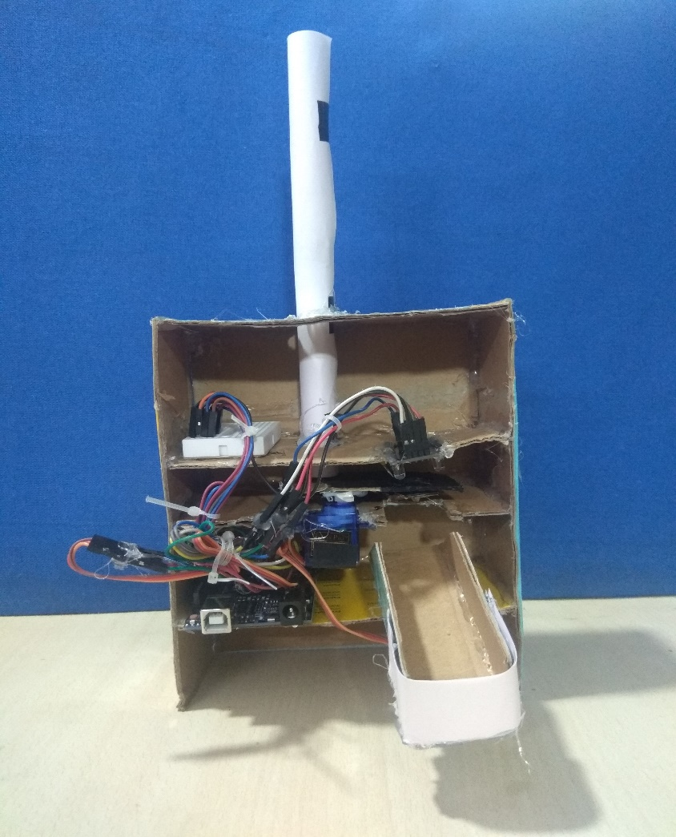

**COMPONENTS:**

* Arduino UNO
* Servo Motors SG90 -2
* Color sensor TCS230 /TCS3200
* Breadboard and Jumper Cables
* 3D printed box

**COLOR SENSOR:**

Color sensor systems are increasingly being used in automated applications to detect automation errors and monitor quality at the speed of production line. They are used in assembly lines to identify and classify products by color. The TCS230 senses color light with the help of an 8 x 8 array of photodiodes. Then using a Current-to-Frequency Converter the readings from the photodiodes are converted into a square wave with a frequency directly proportional to the light intensity.

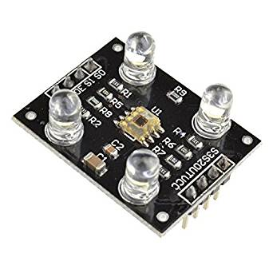

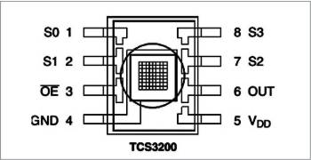

**Function of Pins:**

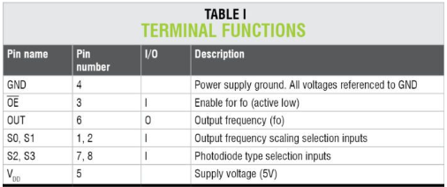

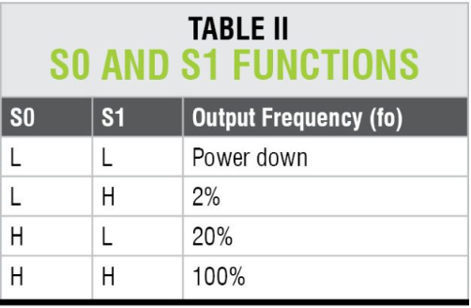

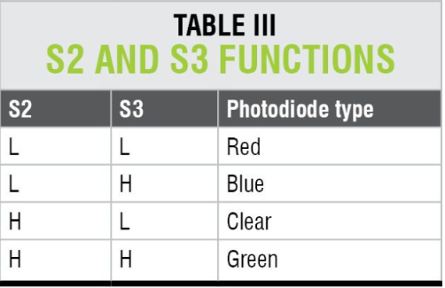

**Arduino Uno**

The Arduino Uno R3 is a microcontroller board based on a removable, dual-inline-package (DIP) ATmega328 AVR microcontroller. It has 20 digital input/output pins (of which 6 can be used as PWM outputs and 6 can be used as analog inputs. Programs can be loaded on to it from the easy-to-use Arduino computer program. The Arduino has an extensive support community, which makes it a very easy way to get started working with embedded electronics.

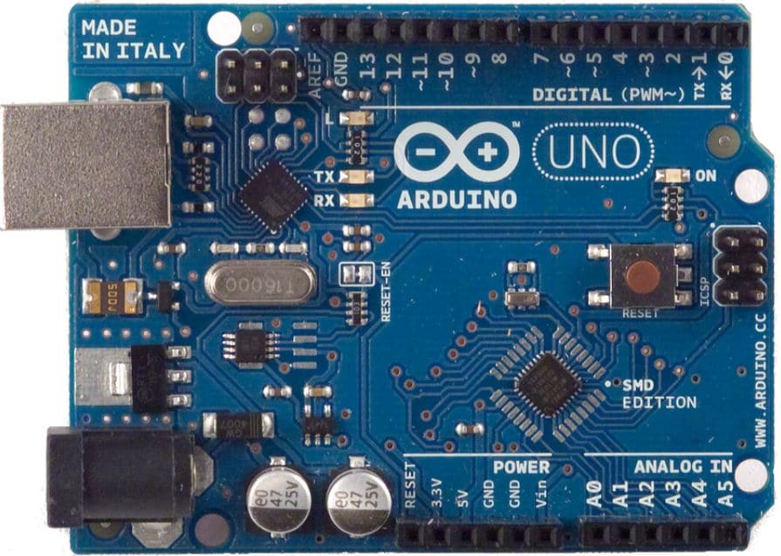

**SERVO MOTOR SG90**

A servo motor allows a precise control of the angular position, velocity, and acceleration. It’s like you’re at the steering wheel of your car. You control precisely the speed of the car and the direction.

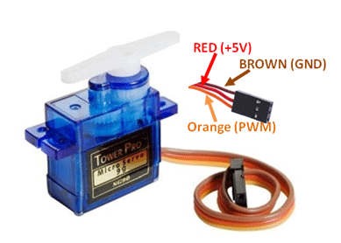

**WORKING PROCEDURE:**

* Initially, the coloured skittles which are held in the charger drop into the platform attached on the top servo motor.
* Then the servo motor rotates and brings the skittle to the color sensor which detects its color.
* After that the bottom servo motor rotates to the particular position and then the top servo motor rotates again till the skittle drop into the guide rail.

**Circuit diagram:**

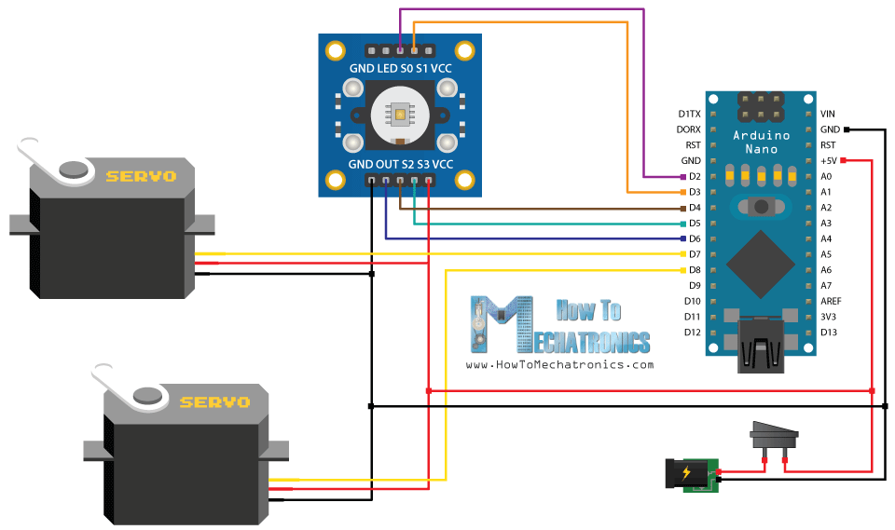

**CONNECTIONS:**

**Arduino UNO Color Sensor**

5V Vcc

GND GND

12 s3

11 s2

10 s1

9 s0

8 OUT

**Arduino UNO Servo SG90**

5V VCC

GND GND

7,5 OUT(1),OUT(2)

**CODE:**

#include <Servo.h>

#define S0 9

#define S1 10

#define S2 11

#define S3 12

#define sensorOut 8

Servo topServo;

Servo bottomServo;

int frequency = 0;

int color=0;

void setup() {

pinMode(S0, OUTPUT);

pinMode(S1, OUTPUT);

pinMode(S2, OUTPUT);

pinMode(S3, OUTPUT);

pinMode(sensorOut, INPUT);

// Setting frequency-scaling to 20%

digitalWrite(S0, HIGH);

digitalWrite(S1, LOW);

topServo.attach(5);

bottomServo.attach(7);

Serial.begin(9600);

}

void loop() {

topServo.write(165);

delay(500);

for(int i = 165; i > 70; i--) {

topServo.write(i);

delay(2);

}

delay(10000);

digitalWrite(S2, LOW);

digitalWrite(S3, LOW);

// Reading the output frequency

frequency = pulseIn(sensorOut, LOW);

int R = frequency;

// Printing the value on the serial monitor

Serial.print("R= ");//printing name

Serial.print(frequency);//printing RED color frequency

Serial.print(" ");

delay(50);

// Setting Green filtered photodiodes to be read

digitalWrite(S2, HIGH);

digitalWrite(S3, HIGH);

// Reading the output frequency

frequency = pulseIn(sensorOut, LOW);

int G = frequency;

// Printing the value on the serial monitor

Serial.print("G= ");//printing name

Serial.print(frequency);//printing RED color frequency

Serial.print(" ");

delay(50);

// Setting Blue filtered photodiodes to be read

digitalWrite(S2, LOW);

digitalWrite(S3, HIGH);

// Reading the output frequency

frequency = pulseIn(sensorOut, LOW);

int B = frequency;

// Printing the value on the serial monitor

Serial.print("B= ");//printing name

Serial.print(frequency);//printing RED color frequency

Serial.println(" ");

delay(50);

if(R>17 & R<50 & G>42 & G<70 & B>31 &B<55){ ///This value should be change according to your reding please check serial monitor to know your reading.

bottomServo.write(45); // Red

}

else if(R>25 & R<45 & G>32 & G<53 & B>33 &B<55){

bottomServo.write(90); // Green

}

// if(R>15 & R<18 & G>18 & G<25 & B>15 &B<35){

// color = 3; // Yellow

// }

else if(R>30 & R<62 & G>35 & G<75 & B>25 &B<60){

bottomServo.write(130); // Blue

}

delay(300);

for(int i = 70; i >50;i--) {

topServo.write(i);

delay(2);

}

delay(400);

//

for(int i = 50;i< 165; i++) {

topServo.write(i);

delay(2);

}

}